Task 1:

**Write simple calculator**

Html should be like this:

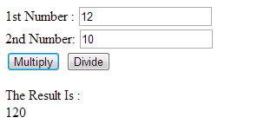

Workflow:

1. Enter 2 numbers in the fields
2. Click on “Multiply” should calculate result and display it on the page
3. Click on “Devide” should calculate result and display it on the page

Special requirement:

You should handle situations when calculating is not possible ( for example: 1/”asd”; 1/0, etc… )

When user trying to do impossible calculation you should display alert with error message

Note:

To handle button click you should use addEventListener method

Learn more here - <https://learn.javascript.ru/events-and-interfaces>

You should upload your result to the github repo !

Feel free to ask any questions ☺